

FOR IMMEDIATE RELEASE:
August 13, 2025

JAZZ LEGEND CHARLES LLOYD ANNOUNCES FIGURE IN BLUE
SPACIOUS DOUBLE ALBUM OF NEW STUDIO RECORDINGS OUT OCT. 10
FEATURING A NEW TRIO WITH JASON MORAN & MARVIN SEWELL

LISTEN TO THE LEAD SINGLE “FIGURE IN BLUE, MEMORIES OF DUKE”

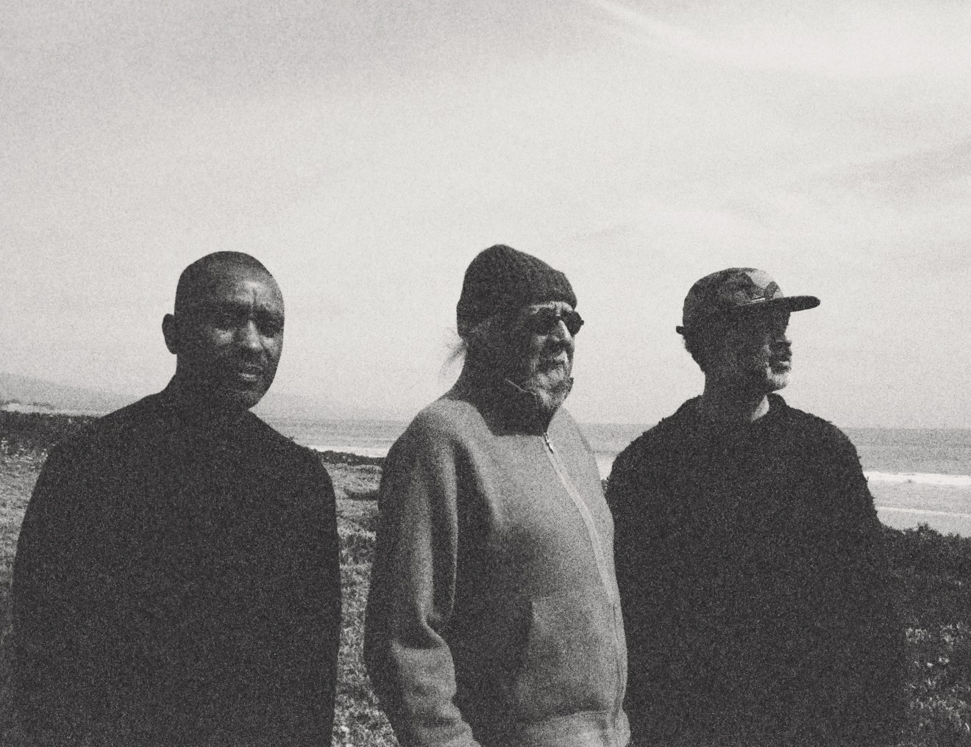
PHOTO BY D. DARR

Jazz legend Charles Lloyd has announced the October 10 release of his latest musical offering, Figure In Blue, a spacious double album of new studio recordings featuring the great saxophonist-flutist in the company of a new trio with pianist Jason Moran and guitarist Marvin Sewell. Lloyd’s 12th Blue Note album travels wide expanses of musical terrain from beautiful ballads to raw Delta blues and includes heartfelt homages to Duke Ellington, Billie Holiday, and Zakir Hussain. Figure In Blue is available for pre-order now on Blue Note Store exclusive color vinyl, black vinyl, CD, and digital download. Listen to the elegant title track “Figure In Blue, memories of Duke.”

Throughout a program of new original music, reinvigorated older works, and other choice selections, Lloyd pays tribute to the musicians and influences that have shaped him. The result is one of the most musically stunning and personally meaningful recordings of his career. In it, you can hear a kind of memoir unfold at the same time the saxophonist puts forth a candid document of his undiminished strength. As he nears his tenth decade, his tone and technique are, as ever, equally mighty and ethereal, delivering startling intensity even in moments of meditative quiet.

Lloyd convened the new trio for his 87th birthday concert at the Lobero Theater in Santa Barbara and immediately brought them into the studio. The trio is a study in ensemble empathy — a clinic in knowing when to play and when to listen — owing to both experience and shared Southern roots. Moran, a generation-defining pianist who was born and raised in Houston, Texas, has been one of Lloyd’s most important collaborators for nearly two decades. “We arrive at the heart of the matter with very few words,” Lloyd says of their kinship.

Sewell has joined Lloyd onstage in various configurations and he’s of a piece with the comprehensive range of Lloyd and Moran’s musicianship. Trained in classical piano and jazz guitar, Sewell also plays bottleneck Delta blues with soul-stirring veracity. “Marvin has an authentic voice,” Lloyd says, going on to explain how Sewell’s playing can transport him to his own musical beginnings in Memphis. “Marvin grew up in Chicago but has family ties to the Mississippi Delta, and knows from first-hand experience the trials and tribulations we experienced on the red clay of the South. You can hear it in his playing.”

Charles Lloyd has done career-defining work in unconventional trio lineups, including Sangam with Hussain, and the more recent recordings collected in the trilogy Trio of Trios. But Figure In Blue stands alone, breaking new ground in the way of harmony, patience, and generosity. By projecting his reverence outward, Lloyd becomes luminous.

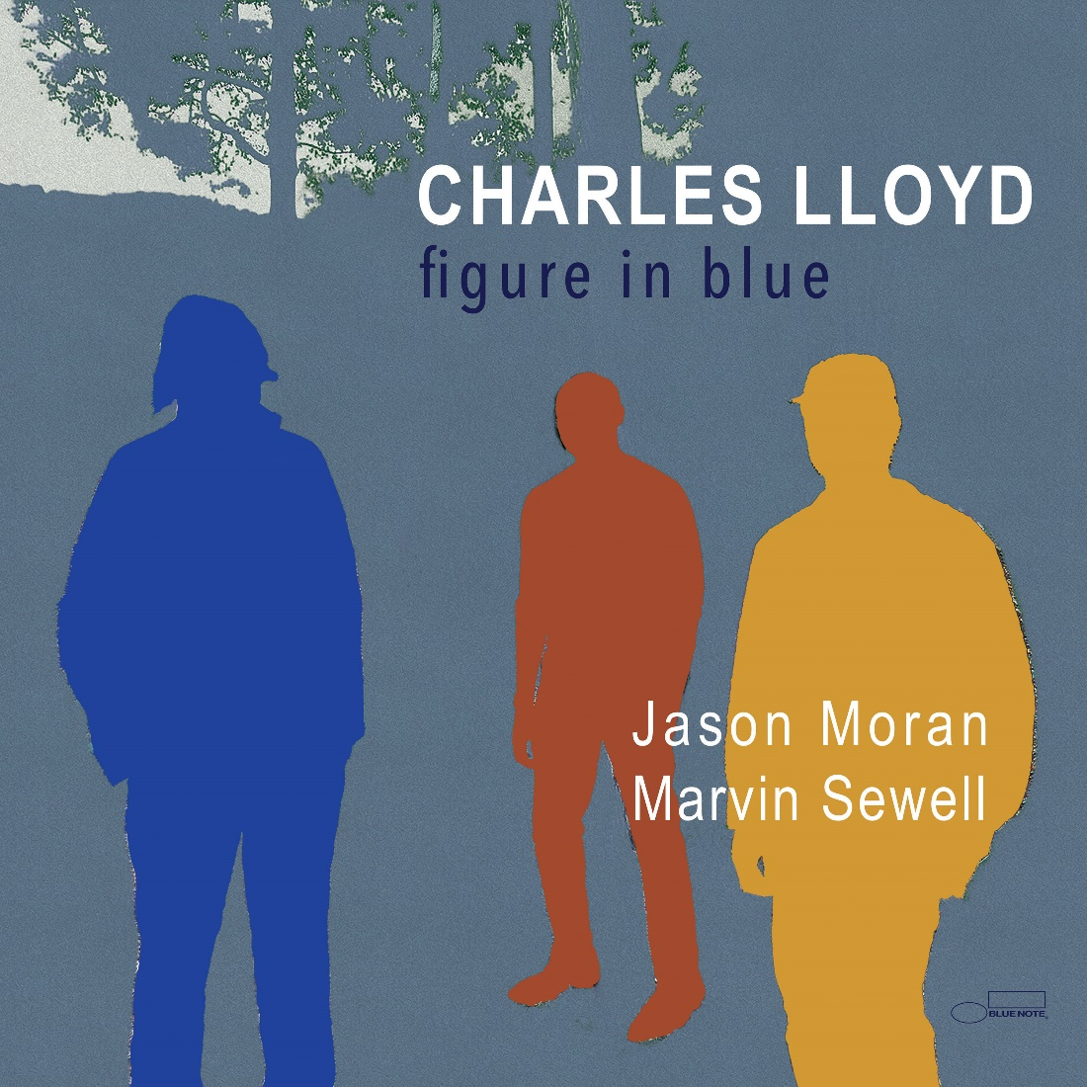

Follow Charles Lloyd:
Website • Facebook • X • Instagram

Follow Blue Note Records:
Website • Facebook • Instagram • Threads • Bluesky • X • Spotify • Apple Music • YouTube

For more information contact Cem Kurosman at Blue Note Records:
(p) 212.786.8634 (e) cem.kurosman@umusic.com

