FOR IMMEDIATE RELEASE:
May 26, 2017

JAZZ MASTER CHARLES LLOYD MARKS
10th ANNIVERSARY OF HIS ACCLAIMED NEW QUARTET
WITH PASSIONATE LIVE RECORDING PASSIN’ THRU
DUE OUT JULY 14 ON BLUE NOTE RECORDS

HEAR THE TITLE TRACK “PASSIN’ THRU”

Charles Lloyd, tenor saxophone & alto flute
Jason Moran, piano
Reuben Rogers, bass
Eric Harland, drums

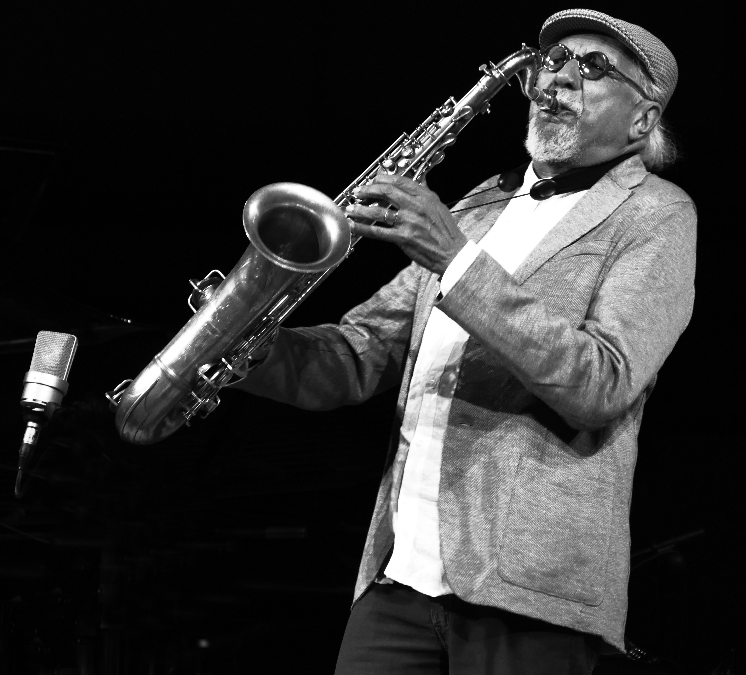
Photo by D. Darr

On July 14, saxophonist, flutist, composer, and jazz mystic Charles Lloyd will release his latest Blue Note offering, Passin’ Thru, a passionate live recording that marks the 10th anniversary of his acclaimed and enduring New Quartet featuring pianist Jason Moran, bassist Reuben Rogers, and drummer Eric Harland, a simpatico unit that teems with intuition, contemplation and playfulness. The album is a dynamic seven-song collection of Lloyd compositions old and new including the swinging and gleeful title track “Passin’ Thru” (first recorded in 1963 when Lloyd was a member of the Chico Hamilton Quintet), which is available today to download or stream.

Lloyd formed his first quartet in 1965 featuring soon-to-be jazz stars pianist Keith Jarrett, bassist Cecil McBee and drummer Jack DeJohnette. Throughout his career he has returned to the quartet format, but he considers his New Quartet formed a decade ago “a landmark group nonpareil.” He elaborates: “It’s a small planet, and we are just passing through on our journey to One. Every now and then there are important intersections. This quartet with Jason, Reuben and Eric coalesced very organically in April 2007. From the notes of our first concert, I knew that it was a magical formation.”

In the summer of 2016, Lloyd reconvened the New Quartet for their first extended tour in several years. In fact, Passin’ Thru opens with the very first song performed on that tour: “Dream Weaver” recorded at the Montreux Jazz Festival on June 30 (the song was originally recorded on his first quartet’s 1966 debut album of the same name). The remaining six pieces were drawn from the band’s sublime performance at The Lensic in Santa Fe, New Mexico on July 29. Lloyd dedicated that concert, as well as this album, to the memory of his dear departed friend Judith McBean (the closing piece “Shiva Dreams” was “a prayer and meditation for her.”)

When asked why he chose to reexamine songs from his past on Passin’ Thru, Lloyd responds, “‘Passin’ Thru’ and ‘Dream Weaver’ are among my many children. They left home and came back. I left home and came back. When we visit with each other we find we have more stories to tell. As they have matured, I have too. When I go out now, I bring many more years of experience that I did not have as an idealistic young man.”

Lloyd marvels at how the New Quartet members “have spread their wings in different ways.” However, he adds, “when we come together as a unit, we find the music and love has only grown deeper. The bond of our shared experiences on and off the stage informs and expands the music. A span of 10 years covers a lot of territory, but in the time frame of the Universe, it is a mere nanosecond.”

The track listing for Passin’ Thru is as follows:

1. Dream Weaver
2. Part 5, Ruminations
3. Nu Blues
4. How Can I Tell You
5. Tagore on the Delta
6. Passin’ Thru
7. Shiva Prayer

* * *

Charles Lloyd is a vital pillar of the triumvirate of living jazz saxophone legends that includes Wayne Shorter and Sonny Rollins. He has spent his entire career on a journey to innovatively explore the spiritual realms of wonder and beauty. In December 2016, the esteemed magazine The Atlantic ran the in-depth profile “The Re-Flowering: Charles Lloyd's Second Golden Age,” proffering that “The jazz saxophonist went from 1960s pop stardom to years of self-imposed exile, but he’s now producing some of the best music of his career.”

Lloyd’s wide recognition in recent years includes being named a 2015 NEA Jazz Master, receiving an honorary Doctor of Music degree from Berklee College of Music in 2015, and last year being inducted into the Memphis Music Hall of Fame. This year he has been honored by the renowned New York jazz cultural center, The Jazz Gallery, with its Lifetime Achievement Award.

Lloyd’s 2015 Blue Note release Wild Man Dance was an album-length suite composed for a unique group comprised of pianist Gerald Clayton, bassist Joe Sanders, drummer Gerald Cleaver, Greek lyra virtuoso Sokratis Sinopoulos, and Hungarian cimbalom maestro Miklós Lukács. For his 2016 album I Long to See You, Lloyd formed a new guitar-driven band featuring guitarist Bill Frisell and pedal steel guitarist Greg Leisz along with Reuben Rogers on electric bass and drummer Eric Harland.

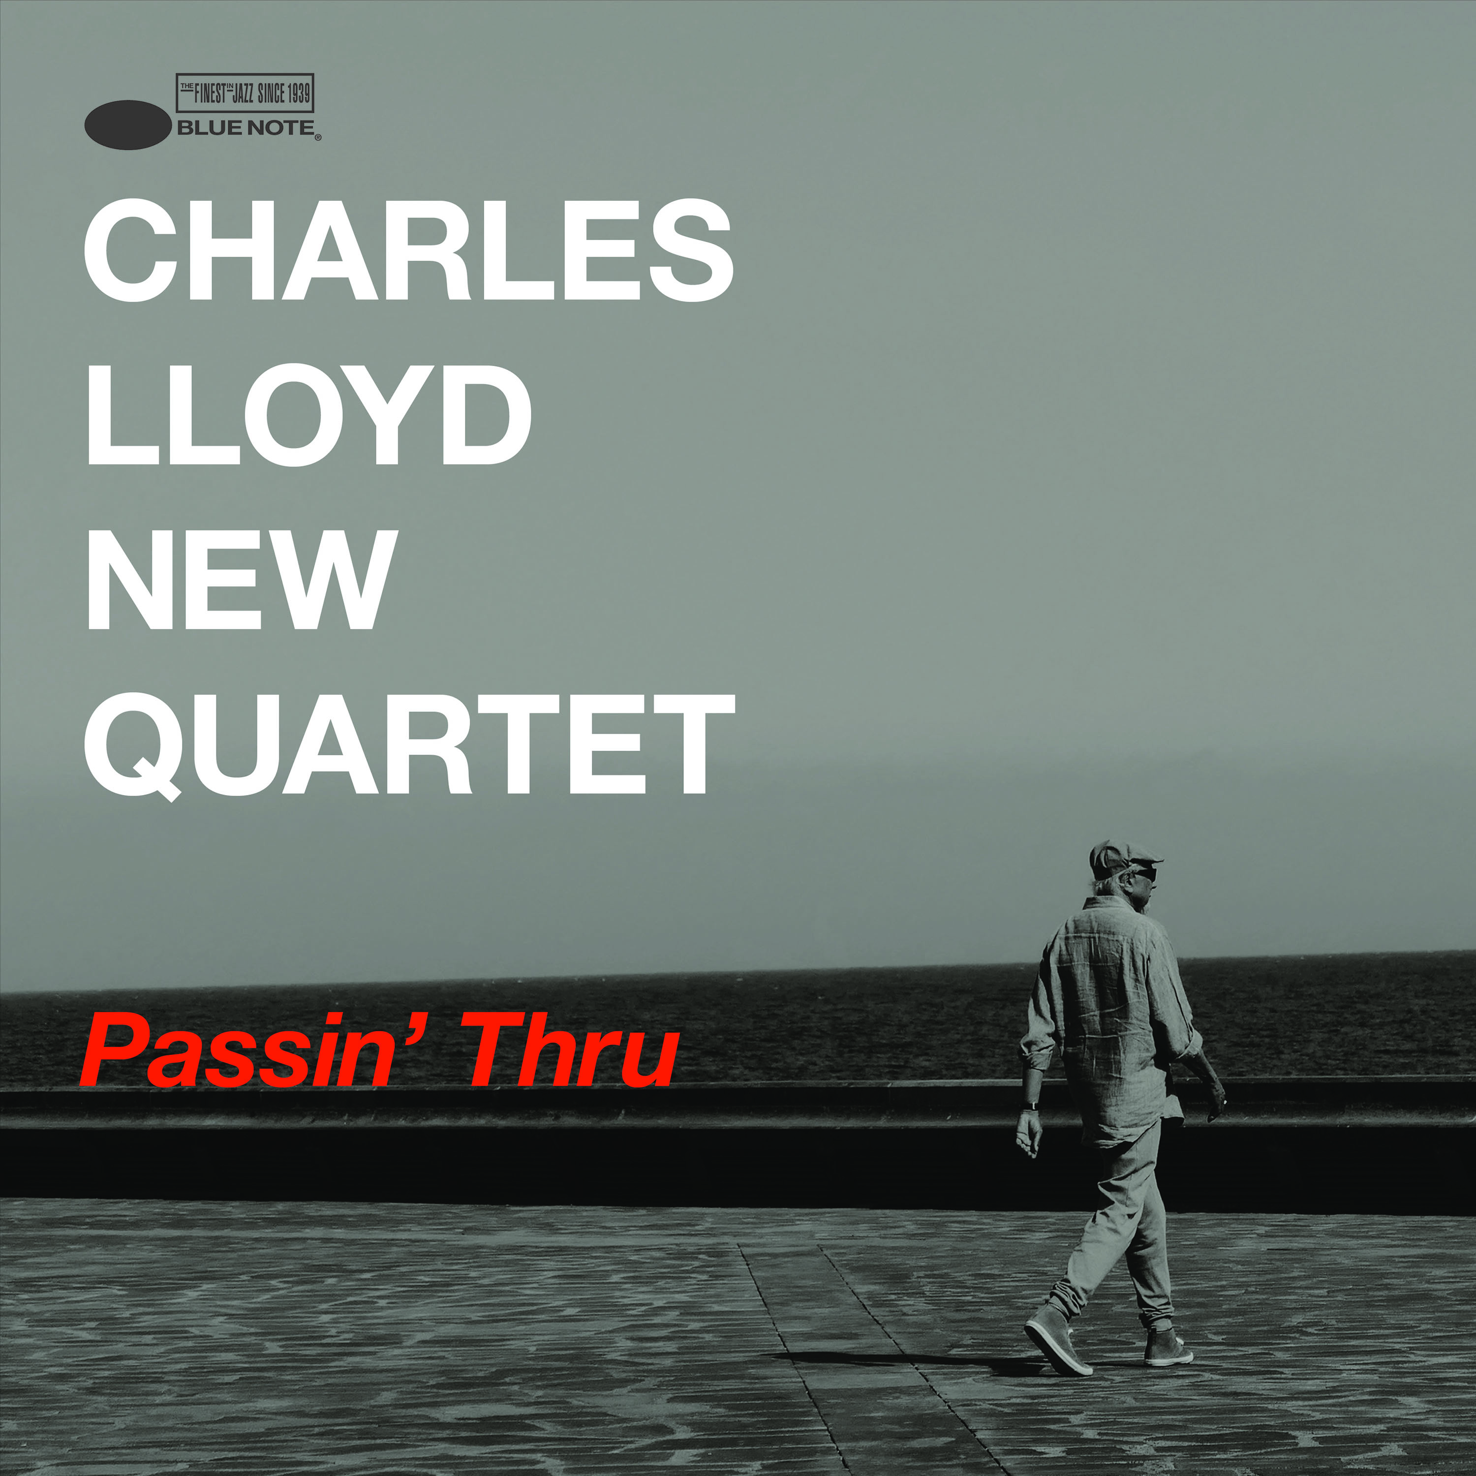

Follow Charles Lloyd:
Website • Facebook • Twitter

Follow Blue Note Records:
Website • Facebook • Twitter • Instagram
iTunes • Apple Music • Spotify • YouTube

For more information contact Cem Kurosman
(p) 212.786.8634 (e) cem.kurosman@umusic.com

