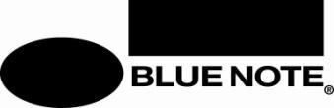

FOR IMMEDIATE RELEASE:
July 15, 2026

MESHELL NDEGEOCELLO ANNOUNCES OCT. 2 RELEASE OF SYNONYM
NEW ALBUM OF DUETS FEATURING AN ASTOUNDING LINE-UP OF SPECIAL GUESTS
COLLABORATING ON STUNNING REINVENTIONS OF CLASSIC SONGS

FEATURING
CYNTHIA ERIVO • CAT POWER • CHAKA KHAN • BRANDI CARLILE •
BILL CALLAHAN • CHRIS THILE • NICK HAKIM • ROBERT GLASPER •
MADISON CUNNINGHAM • LAURA LEE • LIZZ WRIGHT • EMILY KING •
LIANNE LA HAVAS • MOSES SUMNEY • DESTIN CONRAD •
ANOHNI • EVANN McINTOSH • INK • WILLOW

LISTEN TO “I KNEW YOU WERE WAITING (FOR ME)” WITH CYNTHIA ERIVO

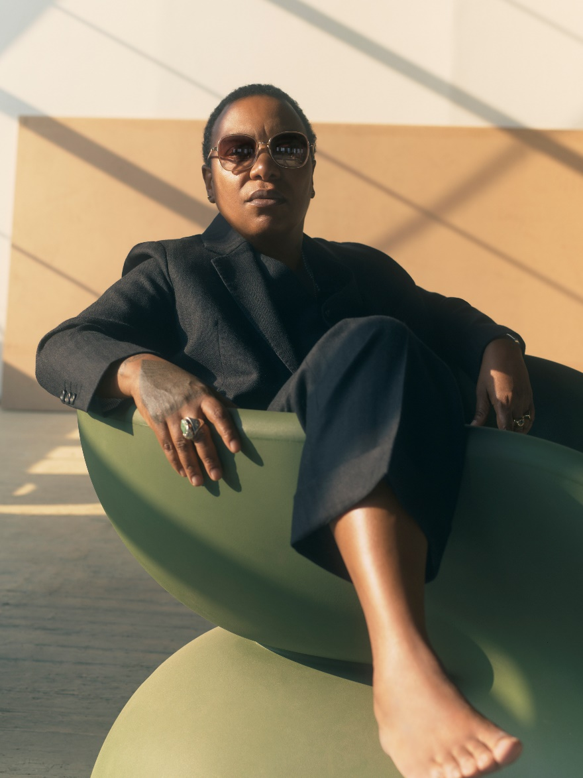
PHOTO BY CHARLIE GROSS

Meshell Ndegeocello has announced the October 2 release of her 3rd Blue Note album Synonym, one of the most ambitious projects in her impressive discography which features an astounding rollcall of special guests reimagining and reconceptualizing a brilliantly curated collection of cover songs. The album—which is available to pre-order now on color vinyl, black vinyl, CD, and digital download—is introduced with the lead track “I Knew You Were Waiting (For Me),” an arresting take on the George Michael/Aretha Franklin duet sung by Ndegeocello and Cynthia Erivo.

Exploring expressions of desire, care, heartbreak, friendship, disappointment, and love in all forms, the songs range from 1960s folk and 70s soul, country, and pop to 80s R&B and electro-boogie, early-90s alternative rock, and early-aughts hip-hop. “This project is about classic songs that are known and loved,” Ndegeocello says. “The songs have diverse tones, representing various genres and intentional grooves. But the album is also about joy, selfhood, individual representation, and universal experience.”

As a multi-instrumentalist – bass being her primary instrument – songwriter, singer, producer, and conceptualist, Ndegeocello emits enough star power to light up the entire solar system. Nevertheless, on Synonym she surrounds herself with an array of guest artists that compose a whole new galaxy of gleaming talent including Cynthia Erivo, Cat Power, Chaka Khan, Brandi Carlile, Bill Callahan, Chris Thile, Nick Hakim, Robert Glasper, Madison Cunningham, Laura Lee (of Khruangbin), Lizz Wright, Emily King, Lianne La Havas, Moses Sumney, Destin Conrad, ANOHNI, WILLOW, Evann McIntosh, and Ink.

The album also notably marks a reunion with David Gamson, the producer of Ndegeocello’s first two classic albums – Plantation Lullabies (1993) and Peace Beyond Passion (1996) – who co-produced Synonym with Ndegeocello and Abe Rounds. A rotating cast of instrumentalists also anchors the music on the album, many of whom are Ndegeocello’s close artistic conspirators, including drummers Rounds and Deantoni Parks; guitarist Chris Bruce; keyboardists Jake Sherman, Jebin Bruni, and Larry Goldings; saxophonists Josh Johnson and Levon Henry; flutist Elena Pinderhughes, banjoist Bela Fleck; and others.

When asked about the album’s intriguing title, Ndegeocello first suggests that the word “just feels good on the mouth,” before expounding upon its true definition: a word or phrase that means the same thing as another word in the same language. “That’s how humans are,” Ndegeocello theorizes, “Regardless of our differences, deep down we essentially want the same things: healthy food and a safe place to live. We are all different. But at the core of the human condition, we are the same.”

“This project is an expression of queer liberation as a synonym for liberation of all kinds,” she continues. “The queer community claimed me when others didn’t and for a long time that felt too far away from other communities to which I belong but now I recognize the ways in which it all overlaps. Once again, I went back to my elders: Audre Lorde told us that there is no single issue struggle. Similarly, these arrangements are synonyms for their originals – these different sounds still mean the same thing.”

A significant aspect of Synonym is that the songs are delivered as duets by people who identify as the same gender. “Or hover around the same continuum of feeling,” clarifies Ndegeocello, acknowledging that gender expression is often fluid. “Hopefully, that’s what stands out – that everyone is well matched musically and complement each other. That said: I’m not defining anything, because the absence of definition is where I feel most free.”

Throughout the album, it’s evident that even though Ndegeocello has long been associated with alternative R&B, her love for all kinds of music weighs more than the importance of genre. She also says that Synonym represents the stage of her career in which her albums don’t need to narrowly center on herself as the main artist. “I want to do more collective music,” she explains. “On this album, I wanted to show off as a producer. I love being on Blue Note Records, because with that, I still get to be a musician.”

Ndegeocello’s first two Blue Note albums – The Omnichord Real Book (2023) and No More Water: The Gospel Of James Baldwin (2024) – have persuasively reasserted her status as an unparalleled force in modern music, earning her the first two GRAMMY Awards to honor her own albums in her three-decade long recording career, exploding any remaining notions of genre boundaries, and coalescing a tight-knit creative circle that operates collectively in the spirit of their motto: MESHELL NDEGEOCELLO IS A BAND.

The tracklisting for Synonym is as follows:

1. I Knew You Were Waiting (For Me) with Cynthia Erivo
2. Don’t You Want Me with Cat Power
3. Don’t Stop The Music with Nick Hakim, Robert Glasper
4. Islands In The Stream with Chaka Khan
5. It Ain't Me Babe with Madison Cunningham
6. Always on Time with Laura Lee
7. Be Real Black For Me with Emily King, Lizz Wright
8. Don’t Look Any Further with Lianne La Havas
9. The Closer I Get To You with Destin Conrad, Moses Sumney
10. Golden Ring with Brandi Carlile
11. I Got You Babe with ANOHNI
12. Here We Come (Here He Comes) with Evann McIntosh
13. Guilty with Ink
14. Hunger Strike with WILLOW
15. With God On Our Side with Bill Callahan, Chris Thile

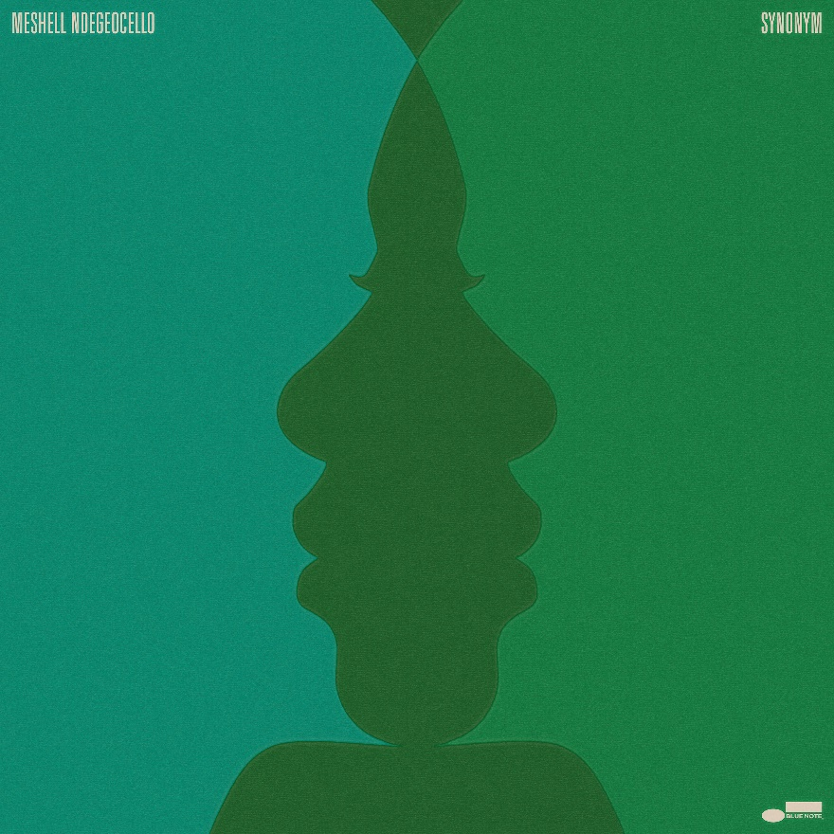

Follow Meshell Ndegeocello:
Website • Facebook • X • Instagram

Follow Blue Note Records:
Website • Facebook • Instagram • Threads • Bluesky • X • Spotify • Apple Music • YouTube

For more information contact Cem Kurosman at Blue Note Records:
(p) 212.786.8634 (e) cem.kurosman@umusic.com

