MORGAN JAMES RELEASES SOUL REMAINS THE SAME

CONCEPT ALBUM BY POWERHOUSE VOCALIST REINTERPRETS ANTHEMS OF HARD ROCK AND METAL, GIVING THEM NEW LIFE IN A FEMININE SOUL REVIVAL

NEWEST VIDEO ALSO OUT TODAY, AN EVOCATIVE COVER OF SMASHING PUMPKINS’ “TONIGHT, TONIGHT”

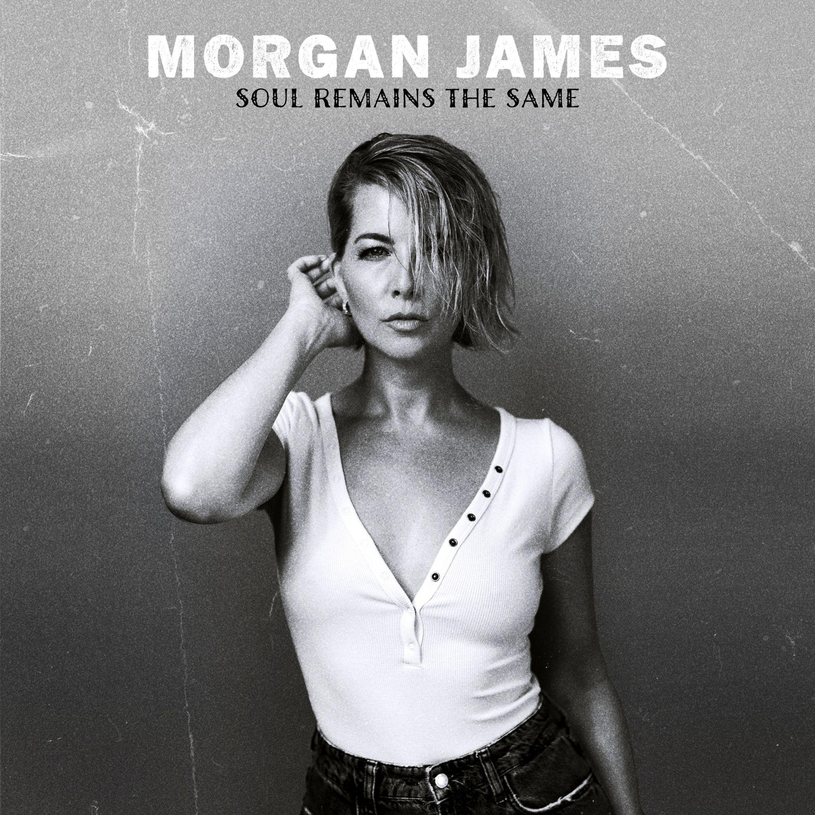

Stream Soul Remains The Same HERE.
Watch the new video for “Tonight, Tonight” HERE.
Download images, bio, and other press materials HERE.﻿

August 8, 2025: Powerhouse soul singer Morgan James today released her newest album, Soul Remains the Same. The unexpected collection follows in the pattern of James’ ever-growing list of concept albums: re-creating iconic music made primarily by men, transforming it into something profound, beautiful and completely new, in a way only a woman could.

Aptly called “a phenomenal talent whose feel for classic soul music is bone deep” by The New York Times, the former Broadway actress and alumna of The Juilliard School, breathes new life into iconic hard rock and metal tracks by artists including Ozzy Osbourne, AC/DC, Pearl Jam, Soundgarden and Metallica.

The newest single from the album is a hauntingly poignant rendition of The Smashing Pumpkins’ 90s hit “Tonight, Tonight.” See the full video of James’ version here.

“‘Tonight, Tonight’ was the last song we added,” says James, “and I knew it was the way I wanted to close the album. When you strip this song down to just keys and voice, the lyrics become the true star. The version we ended up with is a single, complete take—a true performance take of the song, with no edits. This song is so moving, and is the perfect final moment for me.”

Earlier this summer, FemMetal called James’ version of “Plush” (originally written and performed by Stone Temple Pilots) “a bold reinterpretation that feels both timeless and deeply personal…a conversation between genres, eras, and voices.” The outlet also said the entire project has a “bold sound and creative spirit of the project, blending vintage soul textures with songs that were never written with that style in mind.”

Soul Remains The Same follows a series of albums that James has recreated, including reinterpretations of Jeff Buckley’s Grace, D’Angelo’s Black Messiah, and The Beatles’ White Album. She’s also released five albums of original music as a proud indie artist. Two years ago, James released possibly her biggest endeavor to date, Jesus Christ Superstar performed by an all-female cast including Cynthia Erivo (who just concluded her run as Jesus in the much acclaimed Hollywood Bowl production), Shoshana Bean, Ledisi and Bridget Everett. An all female crew of producers and engineers and a female symphony orchestra brought the profound production to life.

James, who is currently on a robust tour combining symphony shows, club dates and everything in between, sees her career as a boundary-less opportunity to create endless music, breathing soul and a fierce, intentioned voice into everything she does.

For more information on Morgan James
Official Site | YouTube | Instagram | Facebook

***

SOUL REMAINS THE SAME
Tracklisting
- Thunderstruck
- Plush
- Sad But True
- The Day I Tried to Live
- Cult of Personality
- Is This Love
- Something I Can Never Have
- Better Man
- Flying High Again
- Tonight, Tonight

UPCOMING TOUR DATES
* Indicates two sets
^ Indicates date in support of Soul Remains the Same

August
8/8 - Charlotte, NC - Middle C Jazz Club*
8/10 - Steamboat Springs, CO - Strings Music Pavilion
8/14 - New York, NY - Dizzy’s Club*
8/15 - New York, NY - Dizzy’s Club*
8/24 - Reno, NV - Nightingale Concert Hall
8/25 - Incline Village, NV - Lake Tahoe Shakespeare Festival at Nevada State Park
8/31 - Budapest, Hungary - Béla Bartók National Concert Hall

September
9/5 - New Albany, OH - Hinson Amphitheater
9/7 - Brampton, ON - The Rose Brampton
9/9 - Toronto, ON - The Great Hall
9/10 - Montréal, QC - Théâtre Fairmount

October
10/3 - Knoxville, TN - Tennessee Theatre
10/9 - Portsmouth, NH - Jimmy’s Jazz and Blues Club
10/10 - Plymouth, MA - Spire Center For Performing Arts
10/25 - New Orleans, LA - New Orleans Jazz Market ^
10/26 - New Orleans, LA - New Orleans Jazz Market ^

November
11/5 - Orlando, FL - Judson’s LIVE *^
11/6 - Orlando, FL - Judson’s LIVE *^
11/15 - Buffalo, NY - Kleinhans Music Hall

December
12/5 - Carmel, IN - Payne & Mencias Palladium
12/6 - Chicago, IL - Park West
12/7 - Ann Arbor, MI - The Ark
12/9 - Columbus, OH - Davidson Theatre
12/11 - St. Louis, MO - Delmar Hall
12/12 - Louisville, KY - Bomhard Theater
12/13 - Bloomington, IN - Buskirk - Chumley Theater
12/14 - Nashville, TN - Country Music Hall of Fame, CMA Theater
12/18 - Newport News, VA - Ferguson Center for the Arts, Peebles Theatre
12/31 - Reading, PA - Santander Performing Arts Center

###

Contact:
Ashley White, ashley@ashleywhitepr.com
Sara Broun: sara@ashleywhitepr.com

